**AUTOMATED SEED SOWING ROBOT**

BY

1. **(Student name)**
2. **(Student name)**
3. **(Student name)**



**Under the Guidance of**

Mentor name

DEPARTMENT OF ELECTRONICS AND COMMUNICATION ENGINEERING

**JSS ACADEMY OF TECHNICAL EDUCATION**

**C-20/1 SECTOR-62, NOIDA**

**MAY, 2021-22**

**Project Report**

**On**

**SEED SOWING ROBOT**

BY

1. **(Student name)**
2. **(Student name)**
3. **(Student name)**



**Under the Guidance of**

Mentor name

DEPARTMENT OF ELECTRONICS AND COMMUNICATION ENGINEERING

**JSS ACADEMY OF TECHNICAL EDUCATION**

**C-20/1 SECTOR-62, NOIDA**

# DECLARATION

We hereby declare that this submission is our own work and that, to the best of our knowledge and belief, it contains no material previously published or written by another person nor material that to a substantial extent has been accepted for the award of any other degree or diploma of the university or other institute of higher learning, except where due acknowledgment has been made in the text.

1. Student name

Roll No.:

1. Student name

Roll No.:

1. Student name

Roll No.:

# CERTIFICATE

This is to certify that Project Report entitled “**Seed Sowing Robot**” which is submitted by **Student name, Student name and Student name** partial fulfillment of the requirement for the award of B. Tech degree in Electronics and Communication Engineering of **Dr. A.P.J. Abdul Kalam Technical University, Lucknow** is a record of the candidate own work carried out by him under my/our supervision. The matter embodied in this thesis is original and has not been submitted for the award of any other degree.

**Mentor name**

**Assistant Professor**

# ACKNOWLEDGEMENT

It gives us a great sense of pleasure to present the report of the B. Tech Project undertaken during B. Tech. Final Year. We owe special debt of gratitude to Mentor name, Department of Electronics and Communication Engineering, J.S.S. Academy of Technical Education, Noida for her constant support and guidance throughout the course of our work. Her sincerity, thoroughness and perseverance have been a constant source of inspiration for us. It is only her cognizant efforts that our endeavours have seen light of the day.

We also take the opportunity to acknowledge the contribution of Head of Department of Electronics and Communication Engineering, J.S.S. Academy of Technical Education, Noida for his full support and assistance during the development of the project.

Name :

Roll No.:

Date :

Name :

Roll No.:

Date :

Name :

Roll No.:

Date :

# 

# ABSTRACT

# Usually the venture from the inspiration of the agriculturists working in their field are exclusively subordinate on the downpours and bore wells for water system of their land. The proposed idea strives to develop a robot capable of performing operations like automatic irrigation, weed controller and determining soil nutrients. It also provides manual control when required. In order to grow nutritious crops and healthy crops farmers need keep in check the right amount of fertilizers. Farmers nowadays spend a part of cash on machines that offer an assistance them diminish work and increment surrender of crops but the benefit and effectiveness are exceptionally less. Consequently, robotization is the perfect arrangement to overcome all the inadequacies by making machines that perform one operation and robotizing it to extend abdicate on an expansive scale.

# The robot consists of four subsystems; a four-wheel mobile platform, a digger mechanism, a seed dropping mechanism, and an irrigation mechanism. The robot is remotely operated via an Android application on a mobile phone and all operation data can be monitored via this android application. Additionally, the robot can perform the row-type seed sowing operation in an autonomous mode. The developed agriculture robot has the potential to provide an efficient and inexpensive way for future seed sowing applications.

**TABLE OF CONTENTS**

DECLARATION II

CERTIFICATE III

ACKNOWLEDGEMENT IV

ABSTRACT V

LIST OF FIGURES VIII

LIST OF TABLES IX

CHAPTER 1:INTRODUCTION 1

1.1 INTRODUCTION 1

1.2 LITERATURE SURVEY 2

1.3 TRADITIONAL SOWING METHODS 5

1.4 OBJECTIVES OF THE STUDY 5

CHAPTER 2:PROJECT IMPLEMENTATION 6

2.1 WORKING PRINCIPLE 6

2.2 FABRICATION OF SEED SOWING ROBOT 6

2.3 HARDWARE REQUIRED/USED 7

2.4 BLOCK DIAGRAM 7

CHAPTER 3:HARDWARE 9

3.1 HARDWARE DETAILS 9

3.1.1 ARDUINO UNO 9

3.1.2 SOIL MOISTURE SENSOR 10

3.1.3 BLUETOOTH MODULE HC-05 11

3.1.4 MOTOR DRIVER L298D 12

3.1.5 DC GEAR MOTOR 13

3.1.6 MOTOR DRIVER L293D 13

3.1.7 VOLTAGE REGULATOR 7805 14

3.2 PLACEMENT OF HARDWARE COMPONENTS 15

CHAPTER 4:WORKING OF THE PROJECT 16

4.1 SEED SOWING CONTROL ALGORITHM 16

4.2 DIMENSIONS OF THE MODEL 17

4.3 DESIGNING OF THE MODEL 17

4.4 UPLOADING THE CODE IN ARDUINO UNO 18

4.5 CONNECTIONS 18

4.6 ANDROID APP SETUP 19

4.6.1 DEVELOPING ANDROID APP 19

4.6.2 INTERFACING 20

4.7 EXECUTION 21

4.7.1 BASIC FUNCTIONING 21

4.7.2 SEED SOWING MECHANISM 22

4.7.3 DC MOTOR DRIVER 22

4.8 PROJECT COST ESTIMATION 23

CHAPTER 5:OBSERVATION & RESULT 24

5.1 RESULT 24

5.2 BASIC ADVANTAGES OF THE MODEL 26

5.3 APPLICATION 26

5.4 FUTURE SCOPE 26

CHAPTER 6:CONCLUSION 27

6.1 CONCLUSION 27

REFERENCES 28

APPENDICES 29

# LIST OF FIGURES

Fig1. Block Diagram

Fig2: Model with application

Fig3. Arduino Uno

Fig4. Soil moisture sensor

Fig5. Pin configuration of moisture sensor

Fig6. Bluetooth module hc-05

Fig7. Pin configuration of hc-05

Fig8. Motor driver l298d

Fig9. Pin configuration of l298d

Fig10. Dc gear motor

Fig11. Motor driver

Fig12. Voltage Regulator

Fig13: Heatsink

Fig14. Live Model

Fig15. Live Model

Fig16. Algorithm

Fig17. Arduino code IDE

Fig18. Android setup

Fig19. Android setup

Fig20: (a) Weed cutter is off

Fig20: (b) Weed cutter is off

Fig21: Moisture content level is shown

Fig22: Seed dispersal on the ground

Fig23: Arduino Pin configuration

# LIST OF TABLES

Table 1: Literature survey

Table 2: Specifications of atmega328p

Table 3: Pin table Arduino Uno

Table 4: Pin table soil sensor

Table 5: Pin table motor driver l298d

Table 6: Pin table voltage regulator 7805

Table 7: Cost estimation

# CHAPTER 1

# INTRODUCTION

## 1.1 INTRODUCTION

In our nation we don't have adequate apparatus, machinery factors in agricultural zone and it increases the weight of labour on our farmers. So, it’s time to robotize the segment to overcome this issue. In India, 70% human beings rely upon on agriculture. So, we got to study the farming. revolutionary idea of our project is to mechanize the method of Water system and assessment of soil supplements intermittently to surrender nutritious crops. The cultivating framework like water system, weeding, etc. is the diverse prepare. All the forms are development to adjusting the instrument in cultivating which works naturally without the man control necessity.

So, we develop a device for “SEED SOWING ROBOT” the use of microcontroller which is very reasonably-priced and useful. Due to automation the work gotten to be most straightforward, errorless and it spares cash moreover. Our framework is nothing but the four-tire vehicle which is driven by equipped DC motor. Concurring to microcontroller program. It gives data approximately climate conditions of soil supplements. As a result, all the problems of conventional approach are overcome through the usage of this bot. To set up communication between farmer and SEED SOWING ROBOT through Android App for beginning the robot. To control weed with the assistance of cutter.

## 1.2 LITERATURE SURVEY

As the authors (“Kunal A. Dhande, Omkar R. Sahu, Megha S. Bawane, Achal A. Jiwane, Priyanka S. Chaware”) write about developing a system which minimizes working cost, reduces time for digging operation and seed sowing operation, we will take this as our prime objective [1]. In [2] authors talk about sowing seeds in desired position hence assisting farmers in saving time and money. Designing a robot with 4 subsystems-a digger mechanism, a seed dropping mechanism, wheel mobile platform and irrigation mechanism [3]. This paper presented by (“Sweety Dutta, Udit Shanker, Sulekha Katiyar, Venktesh Singh, Mohd. Nayab Zafar, J. C. Mohanta”) has proposed sensor and vision based agricultural robot for sowing seeds. This prototype can navigate it on any agricultural land and perform seed sowing operation simultaneously. The swarming technology can be incorporated to use multiple robots to reduce sowing time [4]. The novelty of the proposed low cost indigenously developed modular vehicle lies in design of its seed sector with extremely low miss rate distinguishes the vehicle from other designs [5]. This paper offers the idea of a new era of smart, flexible and interconnected independent robotic device operating with human co-employees in farms and food factories [6]. An autonomous seed sowing robot is designed which divides the field into a grid with intersection points as places where seeds are sown. Sensors are used for obstacle detection [7]. An autonomous robot is designed which switches ploughing system optionally when required [8]. The proposed idea is based on wireless sensor nodes for sensing field parameters of irrigation system like temperature and soil moisture. It makes use of multiloop networking for field region communication and additionally gives required facility to the field using Firebird V robot [9]. Agricultural field proposed here prefers automatic control system and it is designed for various wide range of applications [10].

**Table 1: literature survey**

|  |  |  |  |
| --- | --- | --- | --- |
| **S.No** | **Paper** | **Abstract** | **Observation** |
| 1 | Automated Seed Sowing Agribot using Arduino (International conference on Communication and Signal Processing – 2016) | To develop a system which minimizes working cost, reduces time for digging operation & seed sowing operation | The use of Arduino Uno, wifi module and some information about seed sowing mechanism. |
| 2 | IoT Based Seed Sowing Robot  (IRJET-2021) | To sow seeds in desired position hence assisting farmers in saving time & money | With a limited number of agricultural labors, the seed sowing process can be completed in a short time.  Few farmers may feel difficult in using mobile app to control the robot |
| 3 | Development of an agriculture robot for row-type seed sowing applications | Designing a robot with 4 subsystems-a digger mechanism, a seed dropping mechanism, wheel mobile platform & irrigation mechanism. | Information on the digging and seed dropping mechanism was studied. |
| 4 | Sensor and Vision based Autonomous AGRIBOT for Sowing Seeds (ICECDS-2017 | This paper presents the  proposed sensor and vision based agricultural robot for sowing seeds. This prototype can navigate it on any agricultural land  and perform seed sowing operation simultaneously | Use of suspension system is tested and found that it is able to handle bumps up to 3cm.    The swarming technology can be incorporated to use multiple robots to reduce sowing time. |
| 5 | Towards Autonomy in Agriculture: Design and Prototyping of a Robotic Vehicle with Seed Selector (IEEE-2016) | The novelty of the proposed low-cost indigenously developed modular vehicle lies in design of its seed selector. The simple but efficient mechanism of the single seed selector with extremely low miss rate distinguishes the vehicle from other designs | Its function is to pick up a single seed from the bulk of seeds to sow in the soil.  The seeder has to pick up a single seed from the bulk and then transfer it to the planter which helps to sow the seed in the soil. |
| 6 | Agribot – A Multipurpose Agricultural Robot | It is designed for agricultural purposes. Performs various functions involved in farming. | Carry out ploughing in field and assist farmers in improving the efficiency of operations in farms. |
| 7 | Agricultural Robotics: The Future of Robotic Agriculture | It concerns the use of monitoring and intervention techniques to improve efficiency of sensing technologies and automation. The development of precision agriculture e.g. in soil water-content or crop varieties, from farm-scale, down to field-scale, through to sub-field scale. | Use of machinery to automate the farming practices for mass production.  Human robot interaction to help in better results |
| 8 | Development and Fabrication of an Autonomous Seed Sowing Robot (ICCEMME 2019) | To develop a physical structure suitable for the agricultural environment. | Conventional Large size agricultural machines/devices available in market are not pocket friendly and not everyone can avail them. |
| 9 | Smart Agriculture System using Adhoc Networking among Firebird V Bots  (IJIACS 2016) | Agricultural field proposed here prefers automatic control system and it is designed for various wide range of applications. | Proposed design of wireless sensor nodes.  Distributing whole field in grid. |
| 10 | Design and Development of Automatic Operated Seeds Sowing Machine (IJRITCC 2017) | Use of hall effect sensor for conversion of rotation into distance. | Gear system is replaced by hall effect sensor. With this rotation is converted into distance by using controller ATMEGA16 |

## 1.3 TRADITIONAL SOWING METHODS

Conventional methods encompass broadcasting manually, beginning furrows via a rustic plough and dropping seeds hand, and dropping seeds. For sowing in little zones dibbling i.e., making gaps or openings by a adhere or device and dropping seeds by hand, is practiced. Multi push conventional seeding gadget with manual metering of seeds are very prevalent with experienced farmers. Traditional sowing methods have following limitations:

* In manual seeding, it is not feasible to achieve uniformity in distribution of seeds.
* Poor control over depth of seed placement.
* It is necessary to sow at high seed rates and bring the plant population to desired level by thinning.
* Labour requirement is high because two persons are required for dropping seed and fertilizer.

## 1.4 OBJECTIVES OF THE STUDY

* Automate seed sowing with efficiency and accuracy.
* To check the moisture level of soil
* To remove weeds using weed cutter
* Seeds sown at particular distance
* Availabity of two modes i.e. Manual and Automatic modes.

# CHAPTER – 2

# PROJECT IMPLEMENTATION

## 2.1 WORKING PRINCIPLE

The automated seed sowing technology is a technique design so as to lessen the human efforts as it requires less quantity of manmade labour and can be manage efficiently without a professional operator. Seeding physically requires parcels of time, subsequently this innovation eliminates much sum of time with legitimate effectiveness, less time devouring, exactness in sowing seed at particular distance.

It works on simple mechanism, a battery-operated D.C. motor is used transmits the rotary motion to the shaft with the help of motors, and there is another connection of sprocket and chain to the rotary motion. When the farmer puts seeds into the container, seed drops in the seed pipe, which is connected to the furrow opener for the seeding; there is furrow closer for covering the seeds by soil.

## 2.2 FABRICATION OF SEED SOWING ROBOT

The conceptual idea is framed into a three-dimensional model using solid works software. Various calculations are performed. Fabrication of the robot is done by selecting appropriate materials and methods. Usually the time to concentrate on soundness and minimization of wheel sliding. The suspension system can help to maintain the stability of the robot. The suspension system here proposed is a swing axle strut tyre and is designed for a maximum calibre. Wheel choice is executed based on parameters and properties of soil, bearing capacity, foot print range and soil tyre touch strain.

## 2.3 HARDWARE REQUIRED/USED

* Arduino Uno
* Soil moisture sensor
* Bluetooth Module HC-05
* Motor Driver L298N
* DC Gear Motor
* Seed container
* Motor driver L293D
* Voltage regulator 7805
* Motor wheels
* Battery

## 2.4 BLOCK DIAGRAM

BATTERY

ARDUINO

MOTOR DRIVER L298D

MOBILE APP

SOIL MOISTURE SENSOR

WEED CUTTER

SERVO MOTOR

**Fig1: Block diagram**

As it can be seen from the block diagram(fig1), this is the setup of the model. We will be requiring battery as it will be the power source for the model. Battery alone will be powering each component and will be connected to each component directly or indirectly.

We will be using Arduino as our microcontroller for the project. Other components such as moisture sensor, motor driver, servo motor will be connected to Arduino Uno and application used in the project will also be connected to Arduino Uno via Bluetooth module. Use of motor driver is done to allow speed and direction of two motors simultaneously.

Mobile application is used to control the robot so as to perform its functions such as seed sowing, checking moisture content and weed cutting and to make it move in all 4 direction through its control in the application itself. There will be two modes in the application to make robot work and perform its function i.e. manual and automatic. Manual mode will allow the user to control the robot and whereas automatic will have predefined commands which robot will follow.

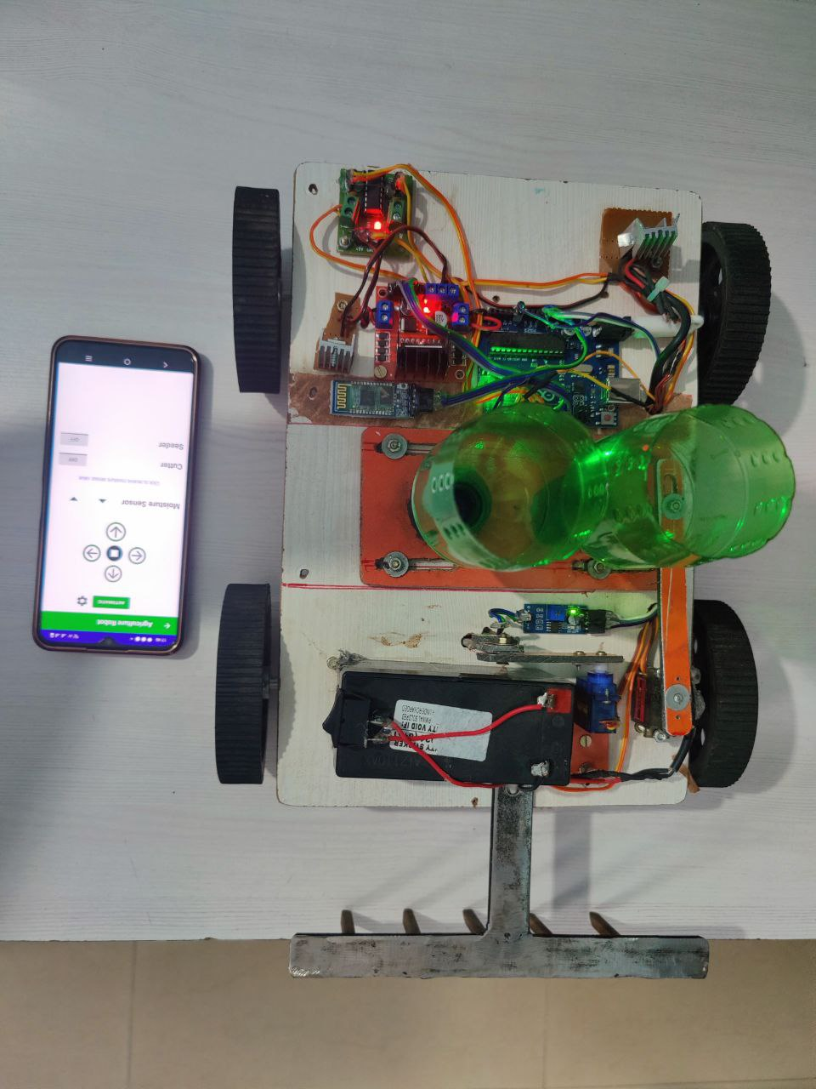

**Fig2: Model with application**

# CHAPTER – 3

# HARDWARE

## 3.1 HARDWARE DETAILS

3.1.1 ARDUINO UNO **–** The **Arduino Uno** is an [open-source](https://en.wikipedia.org/wiki/Open-source) [microcontroller board](https://en.wikipedia.org/wiki/Microcontroller_board) based on the [Microchip](https://en.wikipedia.org/wiki/Microchip_Technology) [ATmega328P](https://en.wikipedia.org/wiki/ATmega328P) microcontroller and developed by [Arduino.cc](https://en.wikipedia.org/wiki/Arduino).[[2]](https://en.wikipedia.org/wiki/Arduino_Uno#cite_note-2)[[3]](https://en.wikipedia.org/wiki/Arduino_Uno#cite_note-What_is_Arduino?-3) The board is equipped with sets of digital and analog [input/output](https://en.wikipedia.org/wiki/Input/output) (I/O) pins that may be interfaced to various [expansion boards](https://en.wikipedia.org/wiki/Expansion_board) (shields) and other circuits.[[1]](https://en.wikipedia.org/wiki/Arduino_Uno#cite_note-Makerspace-1) The board has 14 digital I/O pins (six capable of [PWM](https://en.wikipedia.org/wiki/Pulse-width_modulation) output), 6 analog I/O pins, and is programmable with the [Arduino IDE](https://en.wikipedia.org/wiki/Arduino#Software) (Integrated Development Environment), via a type B [USB cable](https://en.wikipedia.org/wiki/USB_cable).[[4]](https://en.wikipedia.org/wiki/Arduino_Uno#cite_note-princeton-4) It can be powered by the USB cable or by an external [9-volt battery](https://en.wikipedia.org/wiki/9-volt_battery), though it accepts voltages between 7 and 20 volts.

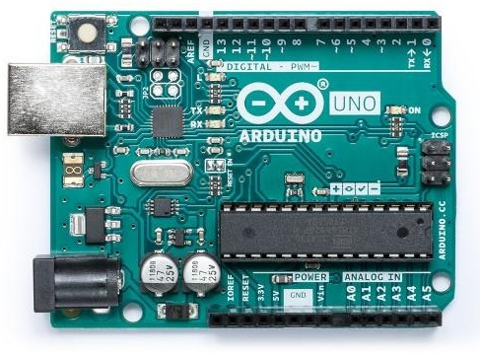

**Fig3. Arduino Uno**

3.1.2 SOIL MOISTURE SENSOR **-** With this module, you can tell when your plants need watering by how moist the soil is in your pot, garden, or yard. The two probes on the sensor act as variable resistors. Use it in a home automated watering system.

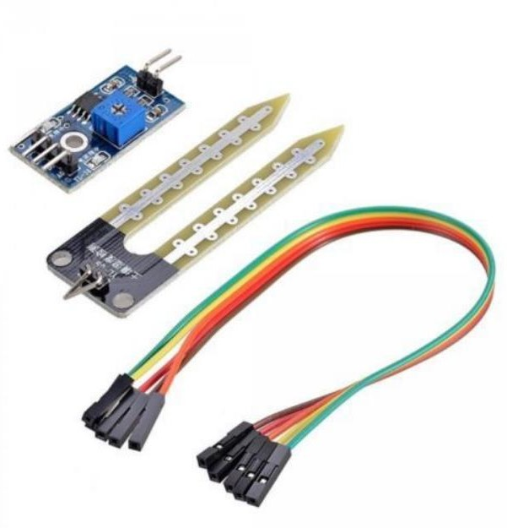

**Fig4. Soil moisture sensor**

## 

## Pin Configuration-

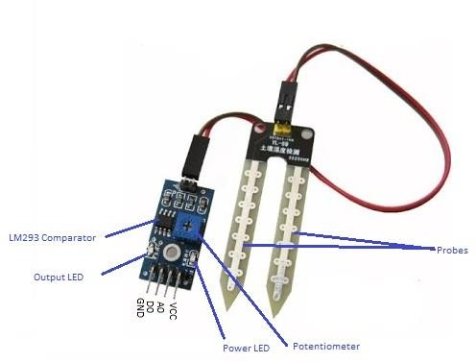

**Fig5. Pin configuration of soil sensor**

3.1.3 BLUETOOTH MODULE HC-05 **-** The Bluetooth Transceiver HC-05 TTL Module (With EN Pin)) Breakout is the latest Bluetooth wireless serial cable. This version of the popular Bluetooth uses the HC-05/HC-06 module. These modems work as a serial (RX/TX) pipe. HC-05 is a Bluetooth module which is designed for wireless communication. This module can be used in a master or slave configuration.

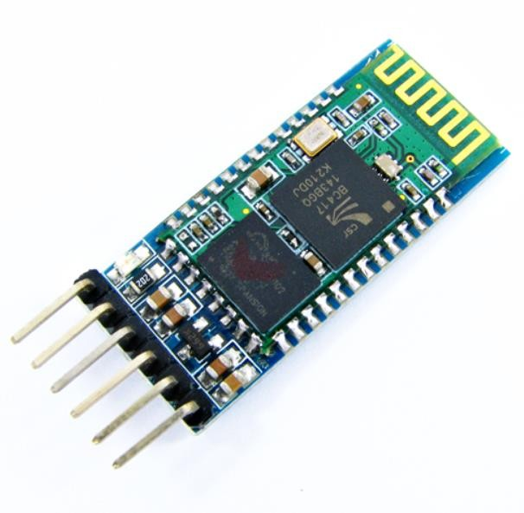

**Fig6. Bluetooth module**

## 

## Pin Configuration

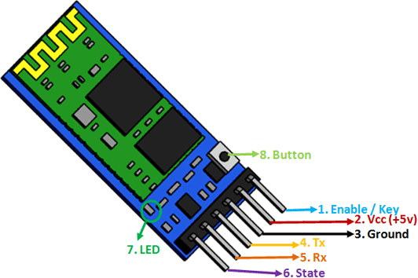

**Fig7. Pin configuration of Bluetooth module**

3.1.4 MOTOR DRIVER L298D **-** It uses the popular [L298](https://robu.in/product-tag/l298n/) motor driver IC and has an onboard 5V regulator which it can supply to an external circuit. It can control up to 4 DC motors, or 2 DC motors with directional and speed control.

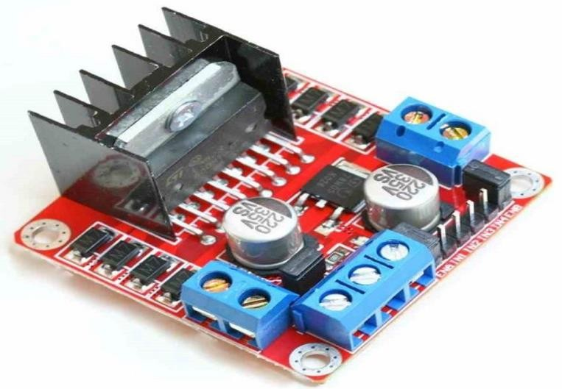

**Fig8. Motor driver L298D**

Pin Configuration: -

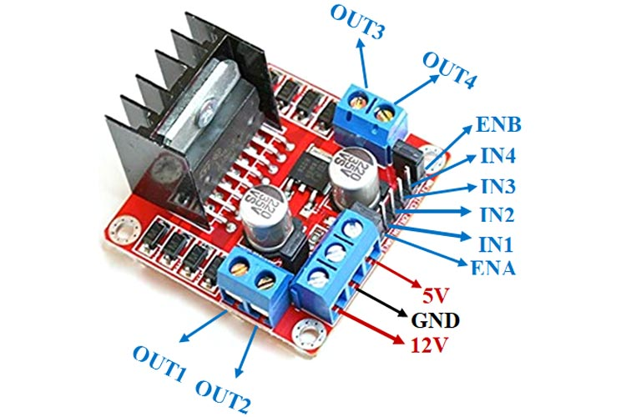

**Fig9. Pin configuration of Motor driver L298D**

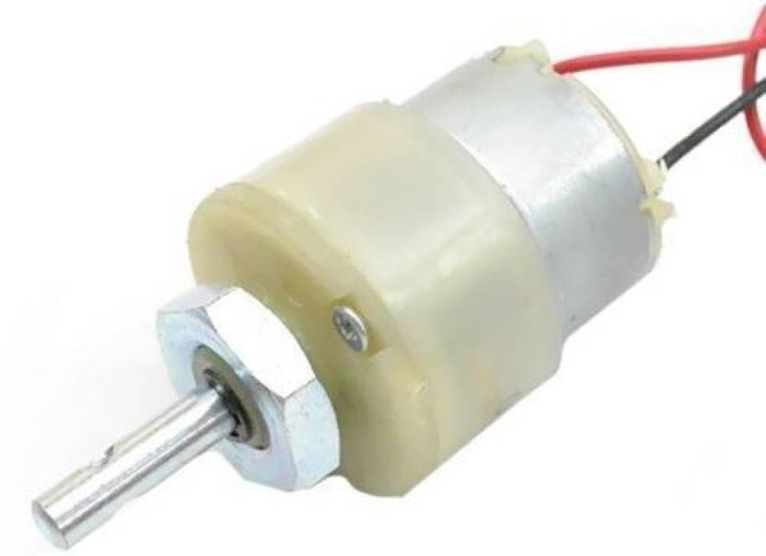3.1.5 DC GEAR MOTOR **-** This can be 12V DC motor which features a gearbox of 45mm distance across. The planetary sort gearbox of this motor features a metal gears and a middle shaft. The Shaft of the motor is stacked with bearing for wear resistance and smooth operation. This shaft contains two settled, North and South, magnets on both sides which causes both a terrible and appealing drive, in turn, creating torque.

**Fig10. DC gear motor**

3.1.6 MOTOR DRIVER L293D - L293D is a basic motor driver integrated chip (IC) that enables us to drive a DC motor in either direction and also control the speed of the motor. The L293D is a 16 pin IC, with 8 pins on each side, allowing us to control the motor. It means that we can use a single L293D to run up to two DC motors. L293D consist of two [H-bridge](https://en.wikipedia.org/wiki/H-bridge) circuit. H-bridge is the simplest circuit for changing polarity across the load connected to it. There are 2 OUTPUT pins, 2 INPUT pins, and 1 ENABLE pin for driving each motor. It is designed to drive inductive loads such as solenoids, relays, DC motors, and bipolar [stepper motors](https://www.etechnophiles.com/guide-to-nema-17-stepper-motor-dimensions-wiring-pinout/), as well as other high-current/high-voltage loads.

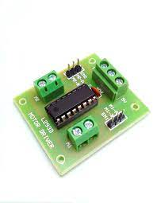

**Fig11. Motor driver L293D**

3.1.7 VOLTAGE REGULATOR 7805 **-** The **7805 Voltage Regulator IC** is a commonly used voltage regulator that finds its application in most of the electronics projects. It provides a constant +5V output voltage for a variable input voltage supply.

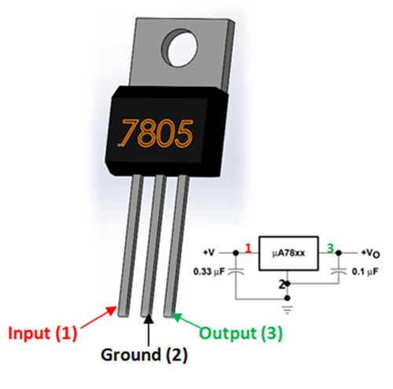.

**Fig12. Voltage regulator**

### 3.1.8 HEATSINK - A heat sink is a component that increases the heat flow away from a hot device. It accomplishes this task by increasing the device's working surface area and the amount of low-temperature fluid that moves across its enlarged surface area.

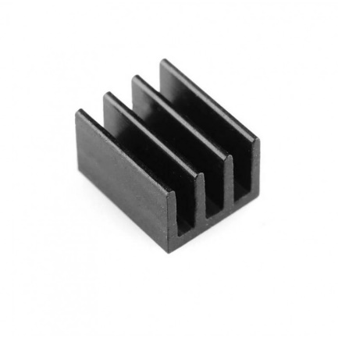

**Fig13: Heatsink**

## 3.2 PLACEMENT OF HARDWARE COMPONENTS

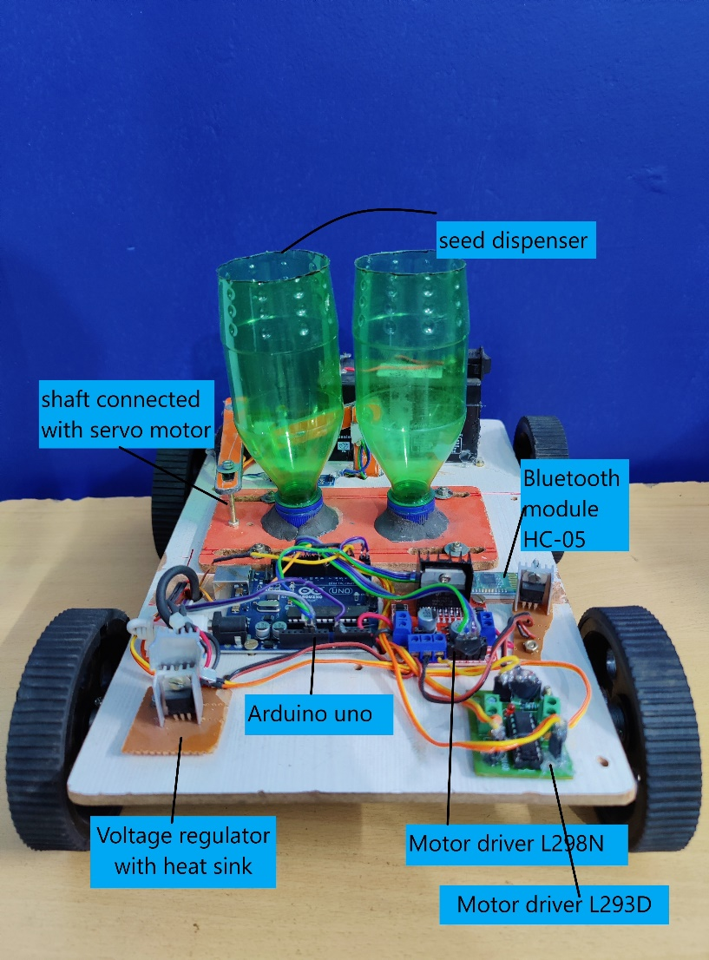

**Fig14. Live model**

.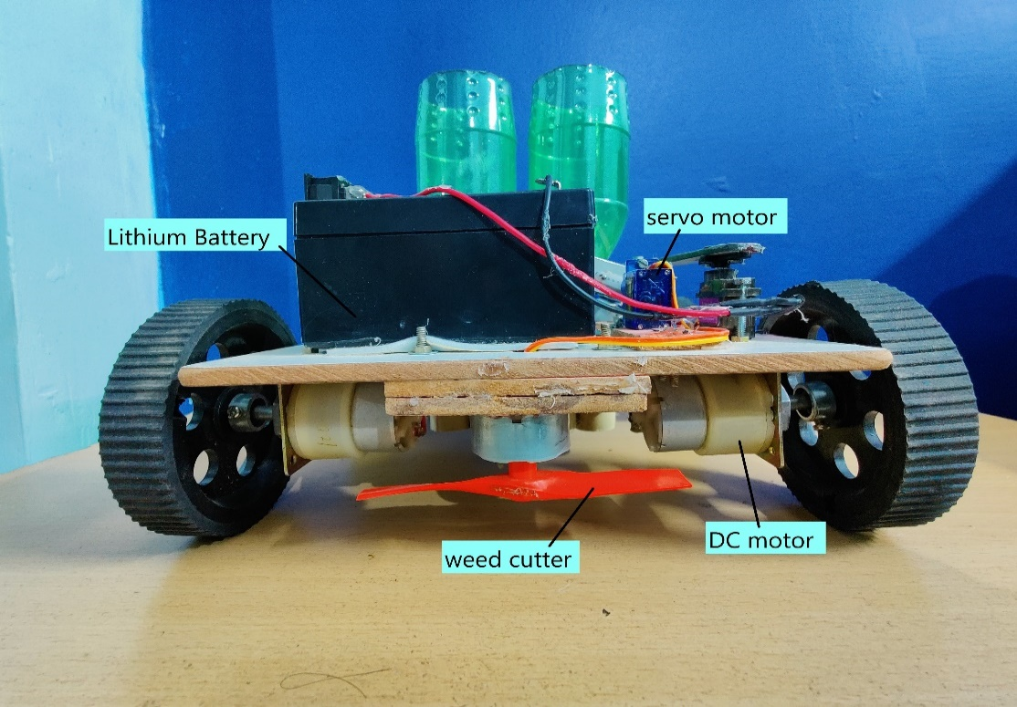

**Fig15. Live model**

# CHAPTER – 4

# WORKING OF THE PROJECT

## 4.1 SEED SOWING CONTROL ALGORITHM

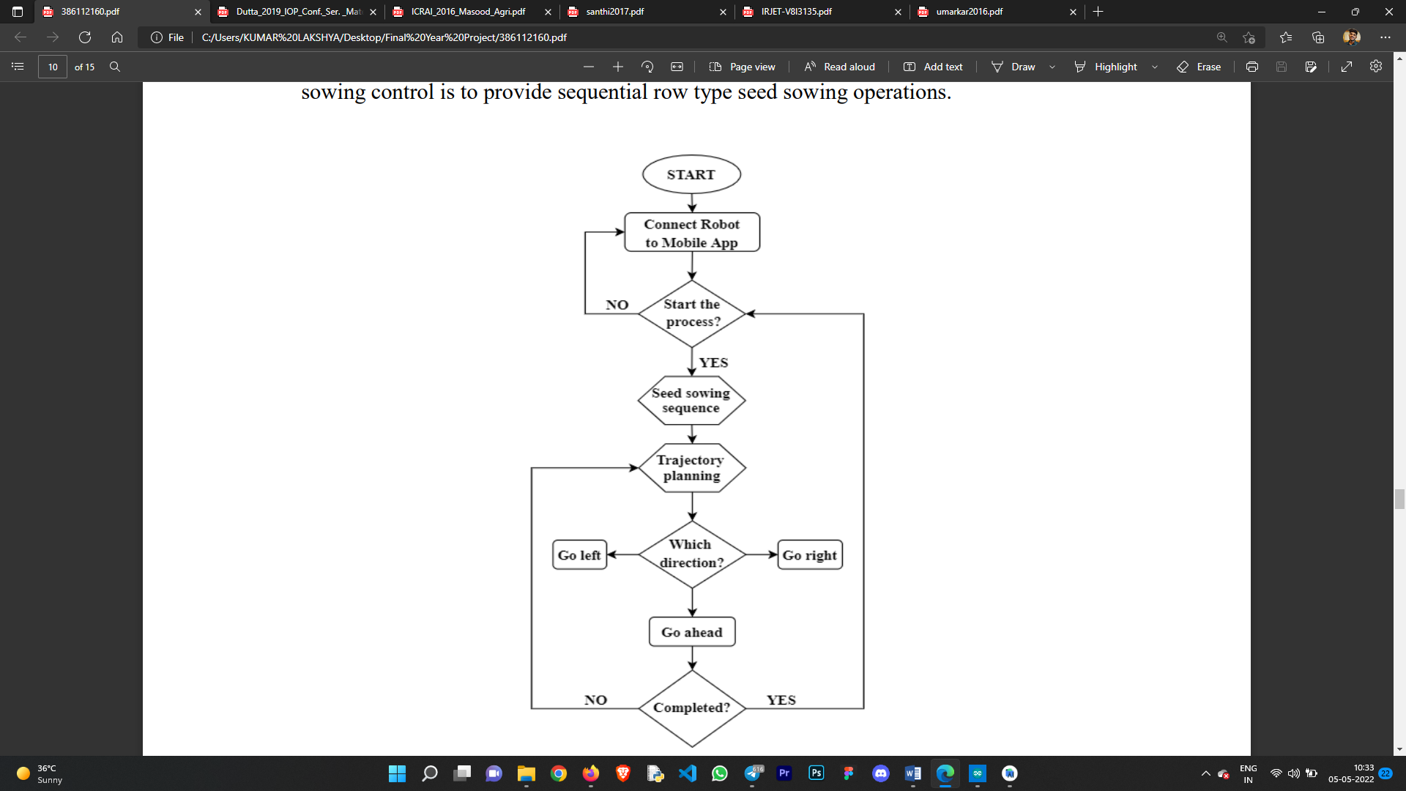

**Fig16: algorithm**

As it can be seen from (fig14) this is the control algorithm includes the seed sowing mechanism. The aim of the seed sowing control is to provide sequential row type seed sowing operations. We can observe that first we need to connect to the mobile application to make progress into later stages. After connecting to application, we need to go for seed sowing mechanism. In the app you will need to put pre-defined commands for trajectory planning for the robot in move in any direction.

Once the trajectory is completed or the commands are fulfilled, it will ask to start the process again so as to make the progress. If yes, it will follow the pathway and if not, it will ask for trajectory or commands once again.

This process will go on loop until the user stops it from his side

## 4.2 DIMENSIONS OF THE MODEL

* Length of model – 30 cm
* Width of the model – 20 cm
* Height of the model – 21cm
* Weight of the model – 2 kg
* Wheel base radius – 9 cm
* Wheel thickness – 2 cm

## 4.3 DESIGNING OF THE MODEL

* Careful placements of the components on the board.
* Uploading of the code to the Arduino Uno.
* Connecting components with the help of jumper wires.
* Connection the Arduino with the android app.
* Remove bugs and errors from the code and the model.
* Start with testing the model.

## 4.4 UPLOADING THE CODE N ARDUINO UNO

Code in arduino is done in Arduino IDE using C sharp language. The code comprises for moisture sensor checker, weed cutter functions, seed dropper mechanism, for the movement of the robot. Various libraries are used in the code which helps in functiong of the whole program much better and smoother.After successfully writing and compiling the code, upload it to the Arduino Uno board**.**

Below is the sample of the code in Arduino IDE,

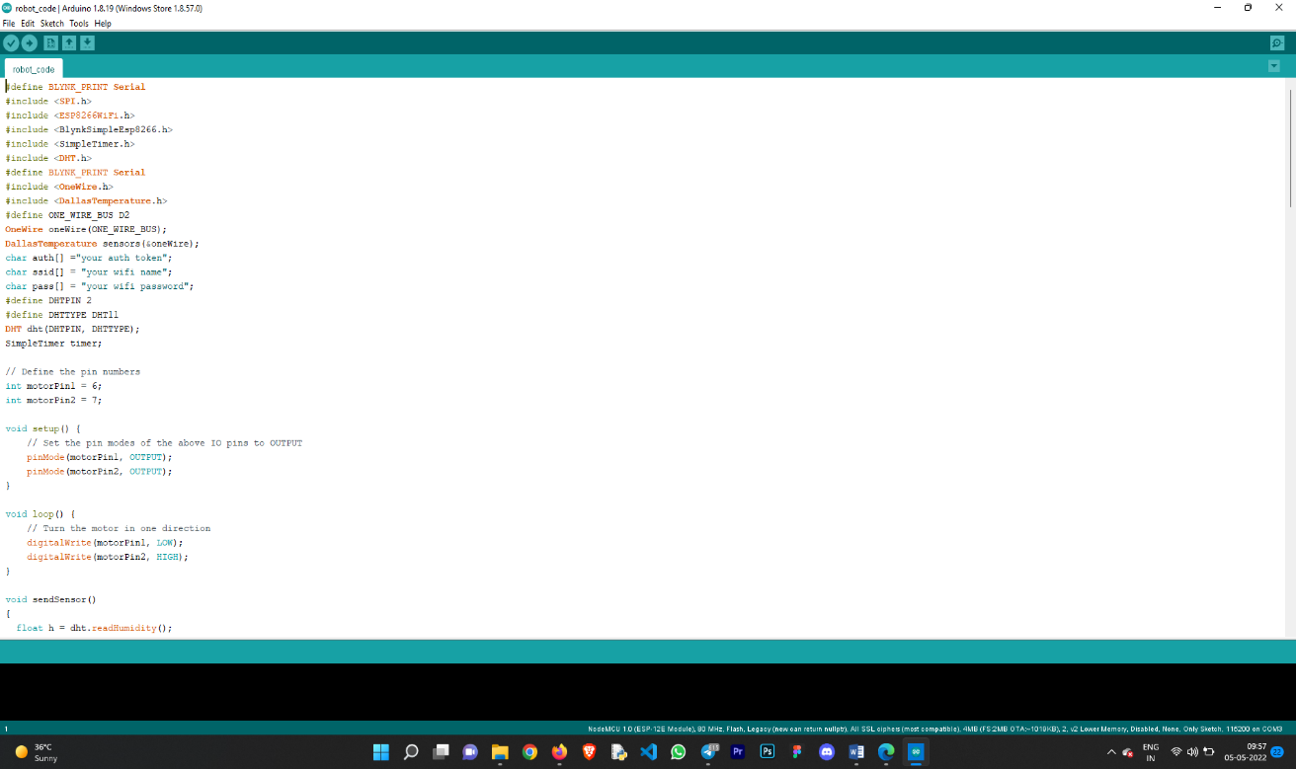

**Fig17. Arduino Uno code**

## 4.5 CONNECTIONS

* Proper connections are made using jumper wires.
* Connections are made looking with the pin configuration of various components.
* Connections with battery should be carefully done.
* No loose are left behind and properly done.

## 4.6 ANDROID APP SETUP

### 4.6.1 DEVELOPING ANDROID APP

As the SEED SOWING ROBOT works with the help of an Android Application, we have developed the android app for the same using Android Studio. Android studio is the platform or software which helps in the creation of application for android environment. With the help of Android Studio application can be written using Java, Kotlin and C++ and several other languages too.

Below is the sample of the code written in android studio,



**Fig18. Android setup**

### 4.6.2 INTERFACING

To allow the communication to happen between Arduino and android application we will be interfacing both with each other. For the connection between the Arduino and android app, we have used several API’s. API is an acronym for Application Programming Interface. It is a kind of software interface or a ton of libraries which allow two applications to communicate with each other.

As we move further, we would be making it easy for the user to know or to direct the use application hence we have developed the UI (User Interface) for the app for better understanding and interfacing. This portion adds the appearance where the user can connect with the app and can command its function.

Below is the sample of the screen where one can see the development of the interface,

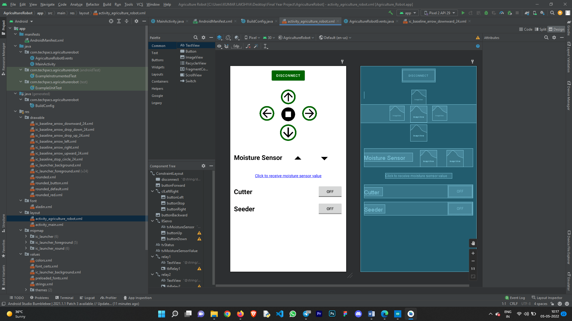

**Fig19. Android setup**

## 4.7 EXECUTION

### 4.7.1 BASIC FUNCTIONING

* To start the functioning of the robot, we should switch on the battery which will provide power to the components.
* After the above-mentioned step, we will connect android application with Arduino using Bluetooth.
* The bot comes equipped with an app for controlling it both ways manually and automatically.
* The Manual feature works like this –
  + When the robot is turned on, the user/farmer can drive it manually throughout the field with the direction enabled in the app for the same purpose.
  + It can be driven in any four of the direction with the controls given and can simultaneously sow the seeds in the soil.
* The Automatic feature works like this –
  + When the robot is turned on, the user/farmer can give predefined commands in the application itself.
  + This will let the robot do the mechanism on its own and drive it following the predefined commands given earlier by the user.
  + It can be driven in any four of the direction with the controls given and can simultaneously sow the seeds in the soil.
* As the bot moves forward, the plank attached to the main framework divides the soil into two and the seed dropping mechanism starts to drop the seed into the soil.
* Later when the seeds have dropped the plough attached at the end of the bot gathers the divided soil and covers the seeds with soil.
* The robot is equipped with features such as moisture monitoring and a weed cutter.
* Moisture sensor allows us to get the moisture content of the soil
* Weed cutter allows us to cut the unwanted plants i.e weeds in the field.
* Both of the features are accessible through application and can be used in the process.

### 4.7.2 SEED SOWING MECHANISM

* For the application of seed sowing, we are using servomotor.
* This is nothing but a simple electrical motor, controlled with the help of servomechanism.
* Shows seed sowing mechanism.
* As the shaft of servomotor can be turned by the required degree which is attached with the hopper containing seeds, the seeds are released/dropped into the soil thus the mechanism of seed sowing is achieved easily.

### 4.7.3 DC MOTOR DRIVER

* A DC motor is an electromechanical device that converts electrical energy that can be used to perform movement of seed robot chassis with the help of L293D IC.
* demonstrated that as power required to run the motors through Arduino is not enough, L293D driver IC is able to achieve the current rating issues.
* It is a Dual DC motor Controller.
* Seed Sowing Robot requires 60 rpm motors so that withstand the complete weight of whole assembly.
* The behaviour of motor for various input conditions.

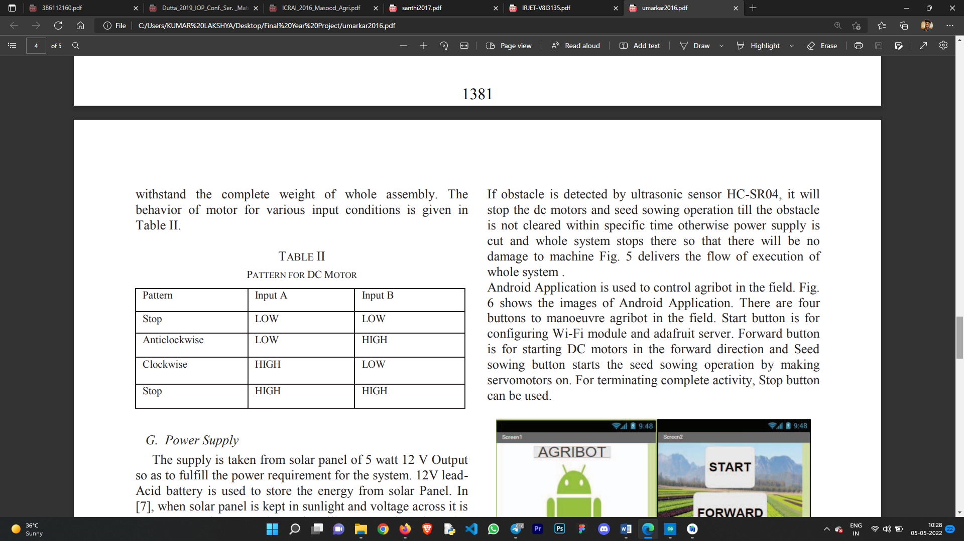

## 4.8 PROJECT COST ESTIMATION

**Table 7: cost estimation**

|  |  |  |
| --- | --- | --- |
| **SR.No** | **Parts Name** | **Cost In Rs** |
| **1.** | Motor (12V 100RPM) | 2000 |
| **2.** | Arduino Uno | 799 |
| **3.** | Charger | 750 |
| **4.** | Battery (12V 9Ah) | 2000 |
| **5.** | Motor Driver L298D | 300 |
| **6.** | Motor Driver L293D | 400 |
| **7.** | Voltage regulator IC | 500 |
| **8.** | Fabrication of Assembly With Components (body) | 1500 |
| **9.** | Wheels | 400 |
| **10.** | Miscellaneous cost | 500 |
|  | Total | 9150/- |

# CHAPTER – 5

# OBSERVATION & RESULT

## 5.1 RESULT

The motive of this project turned into to look beyond the engineering network and to exchange the long-status pattern of self-initiated and out-dated techniques of agriculture. By utilizing this robot, seed sowing packages can be done basically, viably, and eco-friendly. The robot can moreover be utilized for fertilizing and showering pesticides to the selected areas which can be added to the project afterwards.As the robot sow the seeds after indicated and remove the weed from its location and acknowledgment moreover ended up simpler in such a way that each plant that develops between indicated remove is undesirable.

The proposed system gives a compact, low power and low-cost system with an efficient output. Hence the seed placement gives near about accuracy regarding placement of seeds.As the seed sowing robot is serving all the necessary requirement of farmers, it will be the great initiative and contribution to the society.In the future, we try to improve the robot and will design a completely autonomous robot without the requirement of human interaction.

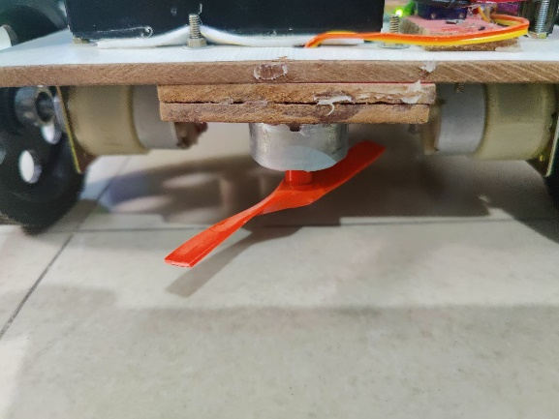 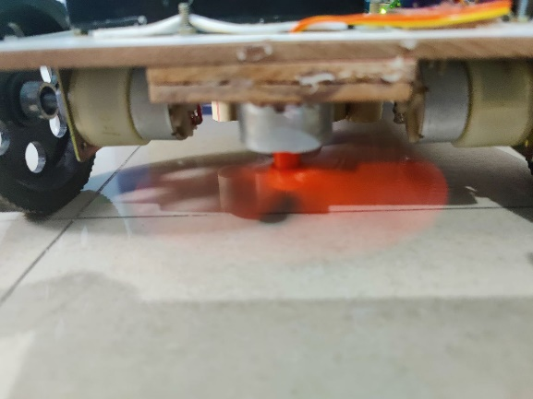

**Fig20: (a)Weed Cutter is off, (b) weed cutter is on**

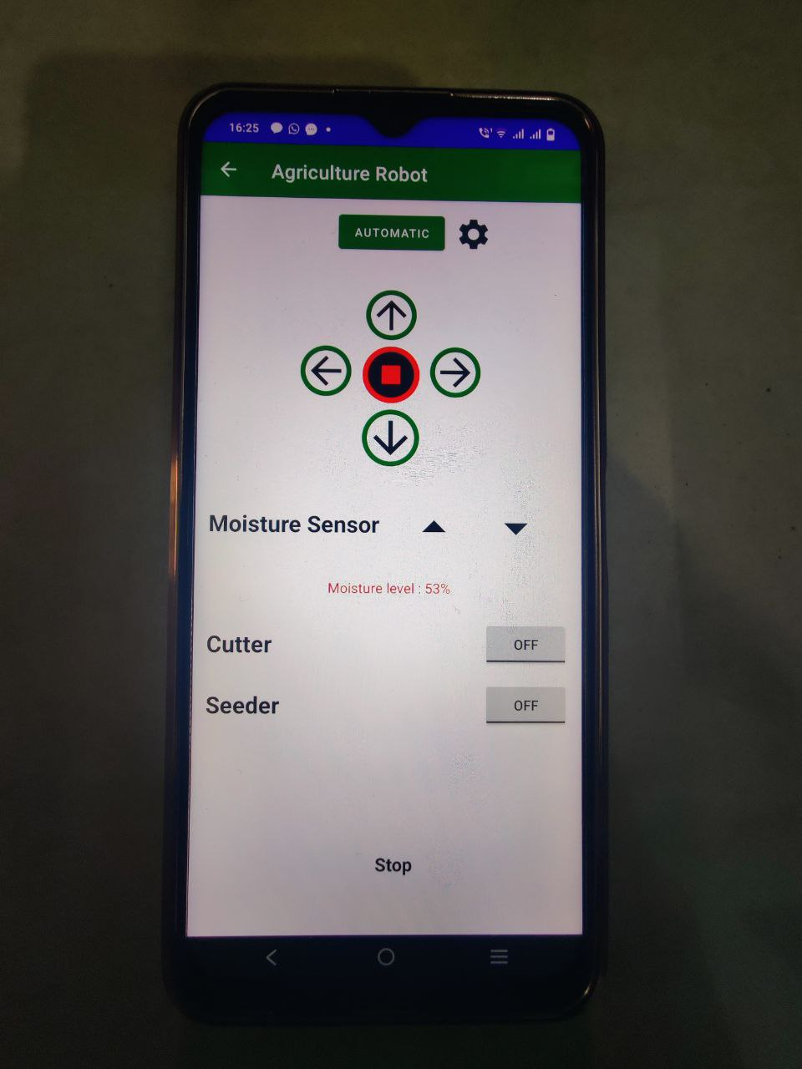

**Fig21: Moisture content level is shown**

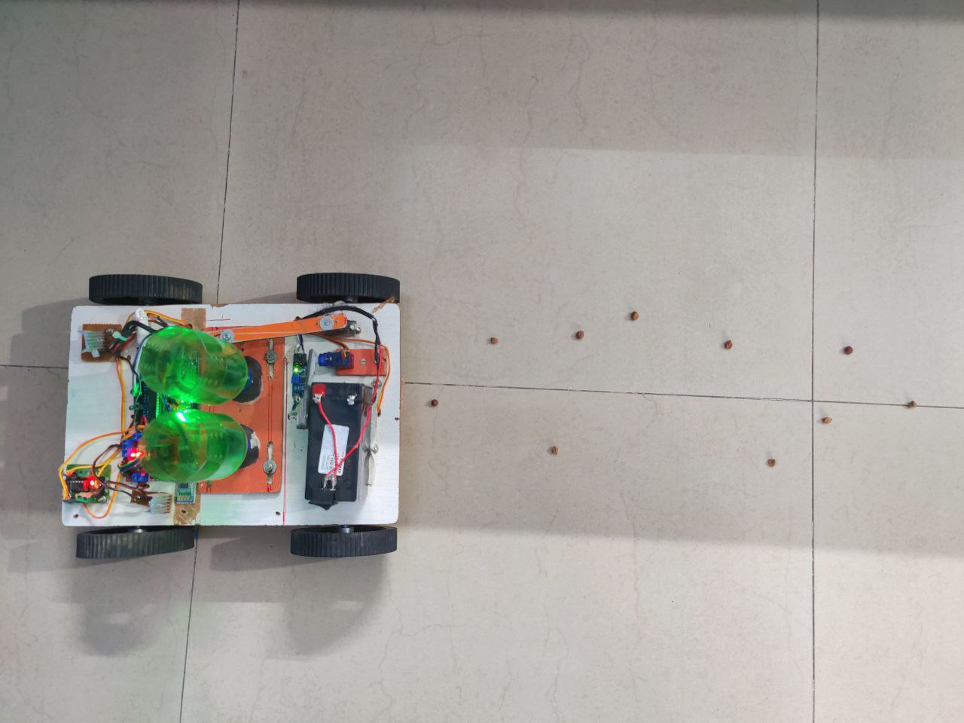

**Fig22: Seed dispersed on the ground**

## 5.2 BASIC ADVANTAGES OF THE MODEL

* These machines are adequately designed with auto seed feeding system planting channel for optimal growing conditions.
* Adjustable seeding rate.
* Seed monitor and hectare counter.
* Spring loaded plunger for seed dropping.
* No extra manpower required.
* It is compact in size.

## 5.3 APPLICATION OF THE PROJECT

* Farming The design of furrow openers of seed drills varies to suit the soil conditions of particular region. Most of the seed cum fertilizer drills are provided with pointed tool to form a narrow slit in the soil for seed deposition.
* Gardening Seeds are broadcasted on the soil which results in the loss and damage of the seeds. As the cost of seeds is more and cannot be affordable for the farmers so there is the need for the proper placement of seeds in the soil.
* Sport’s Stadium The fluted roller seed cup is having the arrangement of seed cut-off and controlling flap to control the amount of seeds and fertilizers.
* Agri Universities the Harrow is one of the important agricultural equipment which is used in the fields of agriculture for seed bed preparation and weed control. This is used before the seeds are sown in the field. As the cost of seeds is more and cannot be affordable for the farmers so there is the need for the proper placement of seeds in the soil.

## 5.4 FUTURE SCOPE

* Introduction of Cutter in place of drill can be used as grass cutter equipment.
* Using remote control machine can be made automatic.
* Addition of multi-hopper can be attached side by side for sowing of large farm.
* Water dripping unit could be included in seed sowing machine.

# CHAPTER-6

# CONCLUSION

## 6.1 CONCLUSION

All the objectives are achieved with maximum results. The moisture sensor installed in the robot works very well and provide the results whereas the weed cutter too shows its

This seed plantation machine has great potential for increasing the productivity of the planting. Till now tractor was the main traction unit for nourishment in farming. With the adaptation of this seed planting machine its purpose will be done. Hence there is need to promote this technology and made available to even small-scale farmers with affordable prices. This machine can be made by raw materials also which saves the cost of whole project and is easily manufactured in available workshops. The only cost is of metering device and sensors. Hence by using this machine we can achieve flexibility of distance and control depth variation for different seeds, hence usable to all seeds.

# REFERENCES

1. Kunal A. Dhande, Omkar R. Sahu, Megha S. Bawane, Achal A. Jiwane, Priyanka S. Chaware, “Design and Development of Automatic Operated Seeds Sowing Machine” , IJRITCC-2017
2. Cihan YURTSEVER, Yasin ERTAS, Oben SUSTAM, Cenk ULU, “ DEVELOPMENT OF AN AGRICULTURE ROBOT FOR ROW-TYPE SEED SOWING APPLICATIONS”, ICAT-2020
3. Tom Duckett, Simon Pearson, Simon Blackmore Bruce Grieve, “Agricultural Robotics: The Future of Robotic Agriculture”, UK-RAS-2018
4. Sweety Dutta, Udit Shanker, Sulekha Katiyar, Venktesh Singh, Mohd. Nayab Zafar, J. C. Mohanta, “Development and Fabrication of an Autonomous Seed Sowing Robot” , ICCEMME-2019
5. Akhila Gollakota, M.B. Srinivas, “AGRIBOT - A MULTIPURPOSE AGRICULTURAL ROBOT”
6. P. VIDUSHINI, SORNA ABISHEK M, SOORIYA KUMAR AR, D. Venkata Nithish Reddy, “IoT Based Seed Sowing Robot”, IRJET-2021
7. Pankaj Kumar, G. Ashok, “Design and fabrication of smart seed sowing robot”, ICAMMM-2020
8. Gayatri Sakya , Ankit Gautam, “Smart Agriculture System using Adhoc Networking among Firebird V Bots”, IJIACS-2016
9. Palepu V. Santhi , Nellore Kapileswar , Vijay K. R. Chenchela , Venkata Siva Prasad. CH, “Sensor and Vision based Autonomous AGRIBOT for Sowing Seeds”, ICECDS-2017
10. Saurabh Umarkar and Anil Karwankar, “Saurabh Umarkar and Anil Karwankar”, IEEE-2016

# Masood Ul Hassan, Mukhtar Ullah, Jamshed Iqbal, “Towards Autonomy in Agriculture: Design and Prototyping of a Robotic Vehicle with Seed Selector”, ICRAI-2016

1. <https://en.wikipedia.org/wiki/Agricultural_robot>
2. https://www.robotics.org/blog-article.cfm/Robotics-in-Agriculture-Types-and-Applications/74
3. https://en.wikipedia.org/wiki/Agricultural_robot

# APPENDICES

1. **Datasheet of Arduino Uno** –

<https://components101.com/microcontrollers/arduino-uno>

**Pin Configuration**

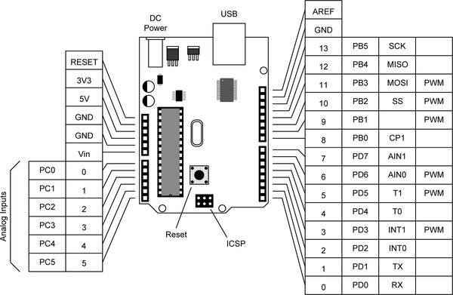

**Fig23. Pin Configuration**

**Table2: pin configuration table of Arduino Uno**

|  |  |  |
| --- | --- | --- |
| **Pin Category** | **Pin Name** | **Details** |
| Power | Vin, 3.3V, 5V, GND | Vin: Input voltage to Arduino when using an external power source.  5V: Regulated power supply used to power microcontroller and other components on the board.  3.3V: 3.3V supply generated by on-board voltage regulator. Maximum current draw is 50mA.  GND: ground pins. |
| Reset | Reset | Resets the microcontroller. |
| Analog Pins | A0 – A5 | Used to provide analog input in the range of 0-5V |
| Input/Output Pins | Digital Pins 0 - 13 | Can be used as input or output pins. |
| Serial | 0(Rx), 1(Tx) | Used to receive and transmit TTL serial data. |
| External Interrupts | 2, 3 | To trigger an interrupt. |
| PWM | 3, 5, 6, 9, 11 | Provides 8-bit PWM output. |
| SPI | 10 (SS), 11 (MOSI), 12 (MISO) and 13 (SCK) | Used for SPI communication. |
| Inbuilt LED | 13 | To turn on the inbuilt LED. |
| TWI | A4 (SDA), A5 (SCA) | Used for TWI communication. |
| AREF | AREF | To provide reference voltage for input voltage. |

* + 1. **Technical Specifications: -**

**TABLE 3: SPECIFICATIONS OF ATMEGA328P**

|  |  |
| --- | --- |
| Microcontroller | [ATmega328P](http://ww1.microchip.com/downloads/en/DeviceDoc/ATmega48A-PA-88A-PA-168A-PA-328-P-DS-DS40002061A.pdf) |
| Operating Voltage | 5V |
| Input Voltage (recommended) | 7-12V |
| Input Voltage (limit) | 6-20V |
| Digital I/O Pins | 14 (of which 6 provide PWM output) |
| PWM Digital I/O Pins | 6 |
| Analog Input Pins | 6 |
| DC Current per I/O Pin | 20 mA |
| DC Current for 3.3V Pin | 50 mA |
| Flash Memory | 32 KB (ATmega328P) of which 0.5 KB used by bootloader |
| SRAM | 2 KB (ATmega328P) |
| EEPROM | 1 KB (ATmega328P) |
| Clock Speed | 16 MHz |
| LED_BUILTIN | 13 |
| Length | 68.6 mm |
| Width | 53.4 mm |
| Weight | 25 g |

1. **Datasheet of HC-05**- <https://components101.com/sites/default/files/component_datasheet/HC-05%20Datasheet.pdf>

**Data mode:** Exchange of data between devices.

**Command mode:** It uses AT commands which are used to change setting of HC-05. To send these commands to module serial (USART) port is used.

**VCC:** Connect 5 V or 3.3 V to this Pin.

**GND:** Ground Pin of module.

**TXD:** Transmit Serial data (wirelessly received data by Bluetooth module transmitted out serially on TXD pin)

**RXD:** Receive data serially (received data will be transmitted wirelessly by Bluetooth module).

**State:** It tells whether module is connected or not.

### ****HC-05 DEFAULT SETTINGS: -****

Default Bluetooth Name: “HC-05”

Default Password: 1234 or 0000

Default Communication: Slave

Default Mode: Data Mode

Data Mode Baud Rate: 9600, 8, N, 1

Command Mode Baud Rate: 38400, 8, N, 1

Default firmware: LINVOR

1. **Datasheet of Soil Moisture Sensor** –

<https://components101.com/modules/soil-moisture-sensor-module>

### ****Soil Moisture Sensor Module Pinout Configuration****

**Table4: pin table of soil moisture sensor**

|  |  |
| --- | --- |
| **Pin Name** | **Description** |
| VCC | The Vcc pin powers the module, typically with +5V |
| GND | Power Supply Ground |
| DO | Digital Out Pin for Digital Output. |
| AO | Analog Out Pin for Analog Output |

## FEATURES: -

* Dual output mode, analog output more accurate
* A fixed bolt hole for easy installation
* With power indicator (red) and digital switching output indicator (green)
* Having LM393 comparator chip, stable
* Operating Voltage: 3.3V to 5V DC
* Operating Current: 15mA
* Output Digital - 0V to 5V, Adjustable trigger level from preset
* Output Analog - 0V to 5V based on infrared radiation from fire flame falling on the sensor
* LEDs indicating output and power
* PCB Size: 3.2cm x 1.4cm
* LM393 based design
* Easy to use with Microcontrollers or even with normal Digital/Analog IC
* Small, cheap and easily available

1. **Datasheet of L298n –**

<https://components101.com/modules/l293n-motor-driver-module>

**Table 5: pin table of motor driver l298d**

|  |  |
| --- | --- |
| **Pin Name** | **Description** |
| IN1 & IN2 | Motor A input pins. Used to control the spinning direction of Motor A |
| IN3 & IN4 | Motor B input pins. Used to control the spinning direction of Motor B |
| ENA | Enables PWM signal for Motor A |
| ENB | Enables PWM signal for Motor B |
| OUT1 & OUT2 | Output pins of Motor A |
| OUT3 & OUT4 | Output pins of Motor B |
| 12V | 12V input from DC power Source |
| 5V | Supplies power for the switching logic circuitry inside L298N IC |
| GND | Ground pin |

### ****Features & Specifications****

* Driver Model: L298N 2A
* Driver Chip: Double H Bridge L298N
* Motor Supply Voltage (Maximum): 46V
* Motor Supply Current (Maximum): 2A
* Logic Voltage: 5V
* Driver Voltage: 5-35V
* Driver Current:2A
* Logical Current:0-36mA
* Maximum Power (W): 25W
* Current Sense for each motor
* Heatsink for better performance
* Power-On LED indicator

1. **Datasheet of L293D –**

<https://www.alldatasheet.com/datasheet-pdf/pdf/89353/TI/L293D.html>

**IN1, IN2, and IN3, IN4** are input pins used for providing a control signal from the controller to run the motor in different directions.

* If input logic at IN1, IN2 is (1,0) the motor rotates in one direction.
* If input logic at IN1, IN2 is (0,1) the motor rotates in the other direction.

**EN1 and EN2** are enable pins. Connect 5v DC to EN1 and EN2 pin to operate the motor at its normal speed

* If speed control is needed, then give PWM output at pin EN1 and En2 from the microcontroller.

**Power for the motor.** If 12V DC gear motor is used then apply 12V.

1. **Datasheet of voltage regulator –**

<https://components101.com/ics/7805-voltage-regulator-ic-pinout-datasheet>

### ****LM7805 Pinout Configuration:-****

### **Table 6: pin description of voltage regulator**

|  |  |  |
| --- | --- | --- |
| **Pin Number** | **Pin Name** | **Description** |
| 1 | Input (V+) | Unregulated Input Voltage |
| 2 | Ground (Gnd) | Connected to Ground |
| 3 | Output (Vo) | Outputs Regulated +5V |

### ****7805 Regulator Features: -****

* 5V Positive Voltage Regulator
* Minimum Input Voltage is 7V
* Maximum Input Voltage is 25V
* Operating current (IQ) is 5mA
* Internal Thermal Overload and Short circuit current limiting protection is available.
* Junction Temperature maximum 125 degree Celsius
* Available in TO-220 and KTE package